**Introduction to Python Programming**

**Assignment No 4**

**“Mini Project”**

CSE-7702



Name of Candidate : Name of Advisor(s)

**Devender Sharma Dr Sandeep Nagar**

Email ID of Candidate : Department, Institute

**devender.sharma@gdgoenka.ac.in Mech Engg Dept**

Enrolment no. Date of Submission

**150020602002 15 Jan 2017**

**Project Report (Mini Project)**

**Aim : To write python code for manually animating an aircraft model (King Fisher airlines A 320 aircraft) in the Vizard IDE as part of the PhD research work on creating the virtual aircraft environment for evaluating aircraft modification proposals.**

**About the PhD Research Work**

The broad scope of the research work is to design and develop a virtual environment for testing / evaluating modification proposals on Airbus A 320 aircraft. This involves

* 1. Conversion of a downloaded 3 D CAD model of Airbus A 320 aircraft to VR format to enable its loading in the virtual environment.
  2. Design and development of Virtual environment for evaluating Integration of Modification units (generated virtually) with the 3D aircraft model.
  3. Displaying feasible mod options considering trim conditions for various flight parameters including stability and control characteristics in the visualized aircraft model.

**Vizard Software.** The Vizard software developed by WorldViz is an ideal software platform for developing VR applications especially for research applications. Vizard has been used at various universities around the world for developing research applications like ours. Also Vizard is available for free online along with features for Virtual Reality interactions, Physics, 3D Modelling, etc. The World Viz Vizard is essentially a middleware that has lot of inbuilt tools to create powerful customized VR applications.  Some of the features include import of 3D models, physics, VR interaction devices, data import, export from simulation models etc. The software also provides a powerful python interface to quickly program complex applications; and see the results on the fly.    Due to its simplicity and availability of default functionality it is used by various research applications.

**Vizard IDE** This essentially comprises of the Vizard workbench that has standard collection of graphical and scripting tools available to Vizard users.  The picture below is a typical view of what the workbench looks like.

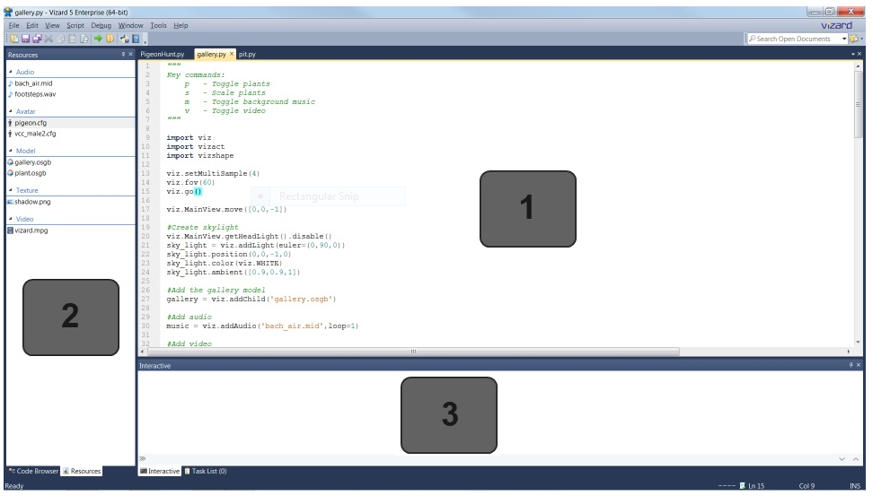

#### Editor [Marked as 1]

The Vizard editor to edit python files (.py) and some common text file formats (.txt, .html).

To open a new Vizard script go to File > New Vizard File or use the Ctrl + N keyboard shortcut.

**Code Browser/Resources [Marked as 2]**

Click on the tabs to toggle between the [Code Browser](mk:@MSITStore:C:\Program%20Files\WorldViz\Vizard5\help\Vizard.chm::/Code_browser.htm) and [Resources](mk:@MSITStore:C:\Program%20Files\WorldViz\Vizard5\help\Vizard.chm::/Script_resource_view.htm) panes. The Code Browser pane displays a hierarchical overview of all the functions and classes within the current script. Double click an item in the browser to jump to the definition location in the editor. This is a useful tool for quickly navigating around large files. The Resources pane lists all the media files referenced by the script. Double click a model, avatar, or texture resource to view.

#### Interactive [Marked as 3]

The [Interactive Window](mk:@MSITStore:C:\Program%20Files\WorldViz\Vizard5\help\Vizard.chm::/Old_Book/Interactive_Window.htm) gives direct access to the Python interpreter and can be used to

* View output and error messages generated by the interpreter
* Send commands to the interpreter and immediately see the response to these commands

**Coding**

**Step 1 :** Import Relevant modules of the Vizard software.

**import viz**

**import vizact**

**import math**

**import vizcam**

The first line is always necessary - it is used to gain access to the entire Vizard library.

**Step 2** : Setting the environment

**viz.fov(60)**

**viz.go()**

The second line, viz.go() starts an empty world.

**Step 3** : Add models.

In the instatnt case, let us add an additional model of a reference tetrahedran using the resource library of the Vizard and also the Airbus A 320 of the Kingfisher airlines. The position of the tetrahedran is also set in the three dimensional co ordinate system

**h = viz.addChild('tut_hedra.wrl')**

**h.setPosition([10,8,25])**

**kingfisher = viz.addChild('D:\\Models\\kingfisher_airlines\\KingfisherAeroplane.ive')**

**Step 4** : Place the model in front of the viewer

It is better to set the position in reference to tetrahedran so that one can visualize the animation aspects on the object of interest i.e. the Airbus A 320 in the instant case

**kingfisher.setPosition([0,0,25])**

**flyNav = vizcam.FlyNavigate()**

**Step 5 :** Add spot lights

The spot lights are added for effective visualization of the animation. In the Ainstant case, two spotlights have been added at the locations as indicated.

**mylight = viz.addPointLight()**

**mylight.setPosition([0,20,6])**

**mylight2 = viz.addPointLight()**

**mylight2.setPosition([0,0,6])**

**Loading and Running the Code**

The code can now be loaded in the Vizrd ID (explained above) for visualisation. A snapshot of the loaded code and subsequent display of the interactive model of the Kingfisher Airlines is shown below:

